Variant Management Sample

Manage relations to Feature and Option used in Expression

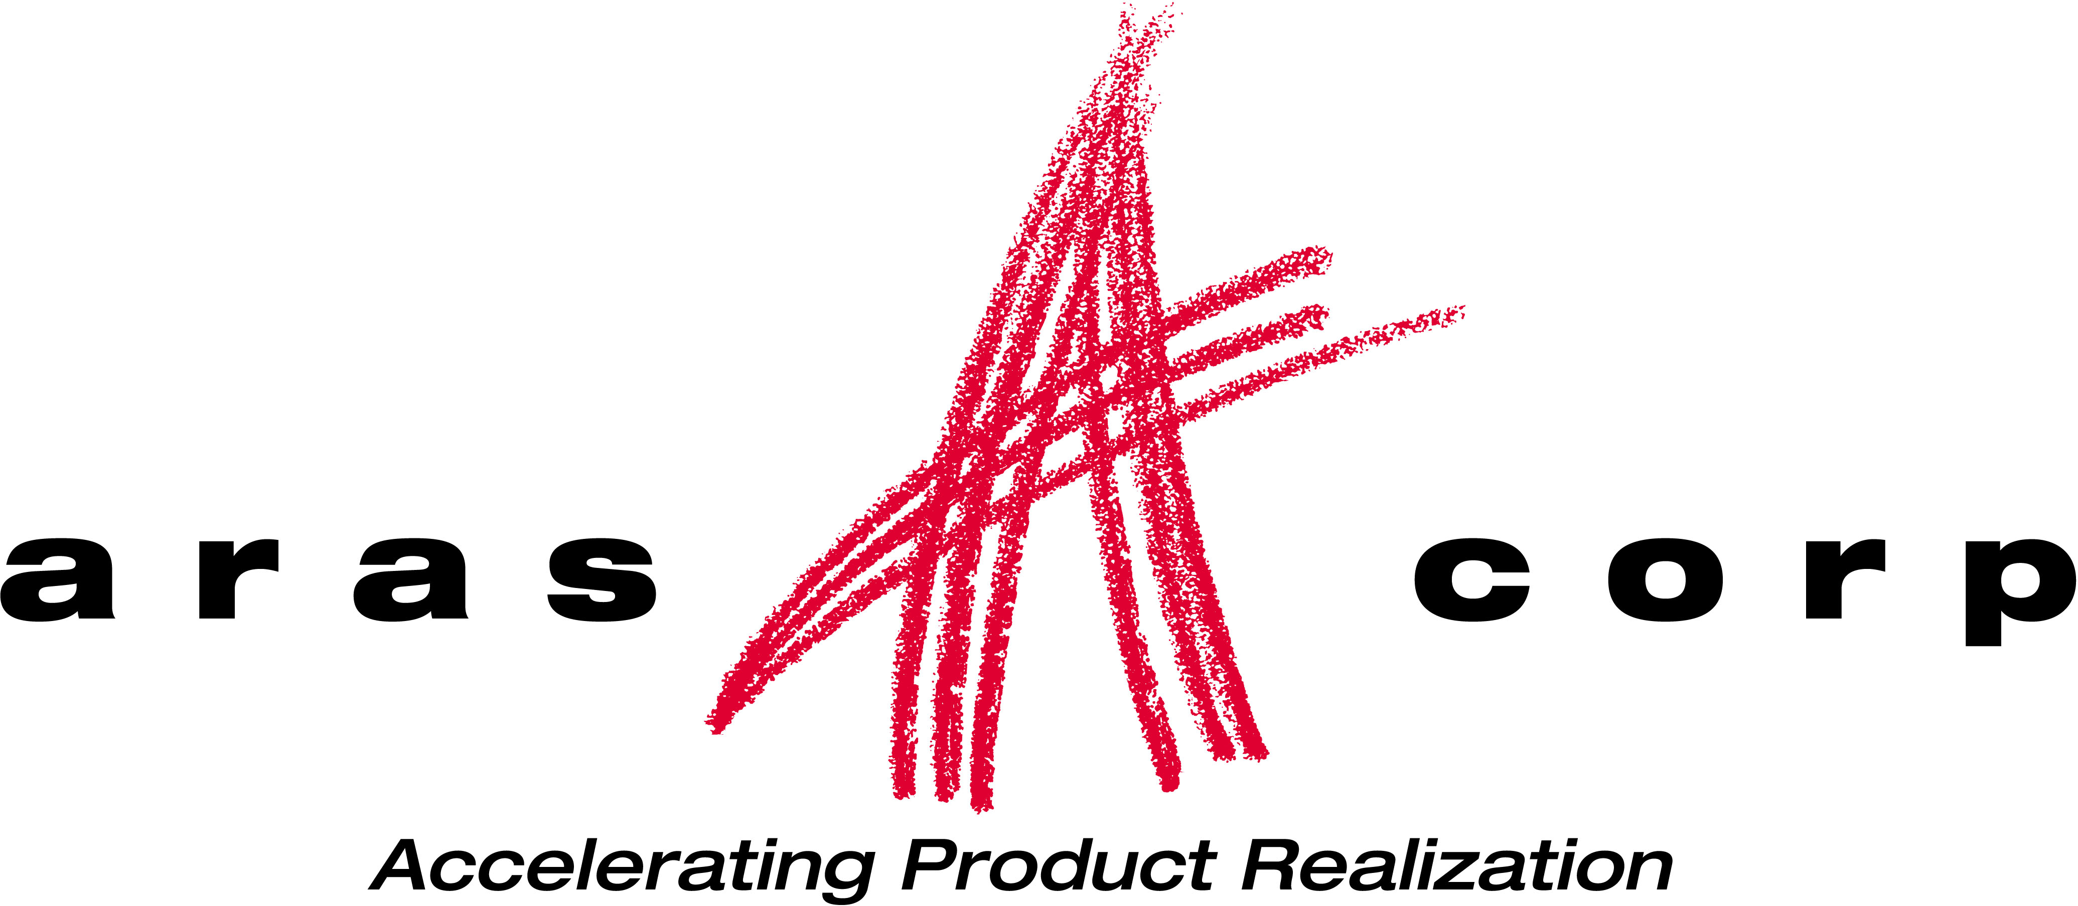

Aras Corporation
© 2002 Aras Corporation. All rights reserved

Aras Corporation
300 Brickstone Square
Suite 700
Andover, MA 01810

Phone: 978-794-7643
Fax: 978-794-9826

E-mail: info@aras-corp.com
Website: http://www.aras-corp.com

Notice of Rights
All rights reserved. Aras Corporation (Aras) owns this document. No part of this document may be reproduced or transmitted in any form by any means, electronic, mechanical, photocopying, recording, or otherwise, without the prior written permission of Innovator and other Aras product names and logos are trademarks of Aras Corporation.

Notice of Liability
The information contained in this document is distributed on an “As Is” basis, without warranty. While every precaution has been taken in the preparation of this document, Aras shall have no liability to any person or entity with respect to any loss or damage caused or alleged to be caused directly or indirectly by the information contained in this document or by the software or hardware products described in it.

NAME | Description of update | Date Updated
Olena Zaporozhets | Initial Creation from TC_003101 | 02/15/2021

Table of Contents

1 Send Us Your Comments 4
2 Overview 5
3 Prerequisites 6
3.1 Server Machine Setup 6
3.2 Client Machine Setup 6
3.3 Make sure notifications about every scripts error enabled in your browser 6
4 Functional Tests 7
4.1 Test Setup 7
4.2 Method for update rel. from vm_ExpressionDefinition 7

Send Us Your Comments
Aras Corporation welcomes your comments and suggestions on the quality and usefulness of this document. Your input is an important part of the information used for future revisions.
- Did you find any errors?
- Is the information clearly presented?
- Do you need more information? If so, where and what level of detail?
- Are the examples correct? Do you need more examples?
- What features did you like most?

If you find any errors or have any other suggestions for improvement, indicate the document title, and the chapter, section, and page number (if available).

You can send comments to us in the following ways:
- Email:
Support@aras.com
Subject: Aras Innovator Documentation
Or,
- Postal service:
Aras Corporation
300 Brickstone Square
Suite 700
Andover, MA 01810
Attention: Aras Innovator Documentation
Or,
- FAX:
978-794-9826
Attn: Aras Innovator Documentation

If you would like a reply, provide your name, email address, address, and telephone number.

If you have usage issues with the software, visit http://www.aras.com/support/

Overview
This test document will go through and validate that the basic functionality of Variant Management Application.

Prerequisites
There are a few prerequisites that need to be done before the test plan can be executed.

Server Machine Setup
- Innovator needs to be set up (refer to the Innovator install guide)
- Vaults need to be set up and functional (refer to the Innovator install guide)
- Your database needs to be a FRESH database with all the correct patches applied to it
- You should have the previous version of Innovator installed on the system as well. (This helps catch installer errors.)

Client Machine Setup
- Clean up cache
  - Delete Browser temporary files
  - Delete assembly files
- If Browser Firefox delete Innovator XPI extension from list of Firefox Add-ons

Make sure notifications about every scripts error enabled in your browser

Functional Tests

Test Setup
Test # | VM-1-001
Purpose: | To prepare instance and data for further testing.
- Download VM build.
- Launch Aras Update.
  - Go to Local tab.
  - Click on “Add package reference”.
  - Select Folder with VM build – Click OK.
    - Confirm that VM Sample is displayed in the list of packages.
- Click on Install – Next – Next.
  - Click on Browse for Install Path field.
  - Select the path of the necessary instance to the Innovator folder.
- Expand Aras Innovator Database Updates.
  - Fill in Server URL, Database.
  - Username: admin.
  - Password: innovator.
- Click on Install.
  - Confirm that VM sample successfully installed.

Add vm_DictionaryItem & vm_ExpessionDefinition include polysource
Test # | TC-003078
Purpose: | vm_DictionaryItem & vm_ExpessionDefinition are added.  Include polysources to added polymorphic itemtypes acording to provided datamodel.
Original requirements: | I-028220 "add vm_DictionaryItem & vm_ExpessionDefinition include polysourc"
Execute | Yes
Test Setup
- vm_DictionaryItem & vm_ExpessionDefinition are added.
- Go to Administration -> ItemTypes -> Search -> vm_DictionaryItem
    - Confirm that vm_DictionaryItem exist.
- Go to Administration -> ItemTypes -> Search -> vm_ExpessionDefinition
    - Confirm that vm_ExpessionDefinition exist.
- Include polysources to added polymorphic itemtypes acording to provided datamodel.
- In vm_DictionaryItem ItemType go to Polysource relshiptab
    - Confirm that: vm_Feature, vm_Option ItemTypes are added.
- In vm_ExpessionDefinition ItemType go to Polysource relshiptab
    - Confirm that: vm_Rule, vm_VarComponentAssetUsage ItemTypes are added.

Add two rel.between vm_DictionaryItem & vm_ExpessionDefinition
Test # | TC-003079
Purpose: | Relationships between vm_DictionaryItem & vm_ExpessionDefinition are added.
Original requirements: | I-028221 "Add two rel.between vm_DictionaryItem & vm_ExpessionDefinition"
Execute | Yes
Test Setup
- Relationships between vm_DictionaryItem & vm_ExpessionDefinition are added.
- Go to RelationShip types -> Search & Open vm_VarCompAssetUsageDictItem
    - Confirm that vm_VarComponentAssetUsageDicItem - Source Item Type
    - Confirm that vm_DictionaryItem - Related ItemType
- Go to Administration -> ItemTypes -> Search & Open vm_ExpressionDefinition
- Go to Polysources relshiptab
    - Confirm that ItemTypes vm_Rule & vm_ VarComponentAssetUsage added
- Open vm_ VarComponentAssetUsage and go to RelationShipTypes relshiptab
    - Confirm that vm_VarCompAssetUsageDictItem added with Name: "vm_DictionaryItem"
- Close vm_ VarComponentAssetUsage
- Open vm_Rule ItemTypes in Polysources relshiptab in vm_ExpressionDefinition
- Go to RelationshipTypes relship tab
    - Confirm that vm_RuleDictionaryItem added with Name: "vm_DictionaryItem"
- Close all Item.
- Go to Administration -> ItemTypes -> Search & Open vm_DictionaryItem
- Go to Polysources relshiptab
    - Confirm that ItemTypes vm_Feature & vm_Option added
- Open vm_Feature and go to RelationShipTypes relshiptab
    - Confirm that vm_FeatureOption added with Name: "vm_Option" and Tap Label - Options

Option can't be removed from a Feature, if that Feature-Option is used in Rule
Test # |  | TC-003198
Purpose: |  | Option cannot be removed from a Feature, if that Feature-Option is used in a Rule
Original requirements: |  | Add server method onBeforeDelete for vm_FeatureOptions
Execute |  | Yes
Test Setup |  | 1. Load VM_Structure.xml using nash  2. Open TestVI1 Variability Item  3. Click Edit  4. Go to Text Rule Editor  5. Create New rule:  TestFeature1 = TestOption1  6. Click Save  7. Go to Relevant Feature tab for VI  8. Select TestFeature1  9. Click Delete Relevant Feature -> Done -> Close VI
Verify that a feature cannot be deleted if it is used in a Rule; even if the feature is not related to a Variability Item.
- Go to TOC -> Variant Management -> Dictionary -> Select loupe for Features
- Click Search
- Select TestFeature1 -> RMB -> More -> Delete -> Delete
    - Confirm that "vm_Feature cannot be deleted. It is used in vm_RuleDictionaryItem related_id ..." error appears
    - Confirm that feature cannot be deleted if it is used in a Rule, even if the feature is not related to a Variability Item
Verify that an option cannot be deleted if it is used in a Rule.
- Go to TOC -> Variant Management -> Dictionary -> Select loupe for Options
- Click Search
- Select TestOption1 -> RMB -> More -> Delete -> Delete
    - Confirm that "vm_Option cannot be deleted. It is used in vm_FeatureOption related_id ..." error appears
    - Confirm that option cannot be deleted if it is used in a Rule
Verify that an option cannot be removed from a Feature, if that Feature-Option is used in a Rule.
- Open TestFeature1 feature -> Click Edit
- Select TestOption1 -> Click Delete Feature Option -> Save
    - Confirm that "Option ... is used in expressions, and cannot be removed" error appears
    - Confirm that option cannot be removed from a Feature, if that Feature-Option is used in a Rule

Postcondition | - Click Discard  - Close TestFeature1  - Open TestVI1 Variability Item  - Click Edit  - Go to Relevant Feature tab for VI  - Click Add Features  - Search -> Select TestFeature1 -> OK  - Click Done -> Close VI

Option can't be removed from a Feature, if that Feature-Option is used in Usage
Test # |  | TC-003199
Purpose: |  | Option cannot be removed from a Feature, if that Feature-Option is used in a Usage.
Original requirements: |  | Add server method onBeforeDelete for vm_FeatureOptions
Execute |  | Yes
Test Setup |  | 1. Load Sample Data  2. Load VM_Structure.xml using nash  3. Open Tire Variabile Component  4. Click Edit  5. Go to Assets tab  6. Select any assets  7. Go to Manage Usage Condition Panel  8. Click Create usage condition  9. Select TestVI2  10. Type expression:  TestFeature3=TestOption5  11. Click Apply  12. Click Done -> Close VC  13. Open TestVI2 Variability Item  14. Click Edit  15. Go to Relevant Feature tab for VI  16. Select TestFeature3  17. Click Delete Relevant Feature -> Done -> Close VI
Verify that a feature cannot be deleted if it is used in a Usage Condition; even if the feature is not related to a Variability Item.
- Go to TOC -> Variant Management -> Dictionary -> Select loupe for Features
- Click Search
- Select TestFeature3 -> RMB -> More -> Delete -> Delete
    - Confirm that "vm_Feature cannot be deleted. It is used in vm_VarCompAssetUsageDictItem related_id ..." error appears
    - Confirm that feature cannot be deleted if it is used in a Rule, even if the feature is not related to a Variability Item

Verify that an option cannot be deleted if it is used in a Usage Condition.
- Go to TOC -> Variant Management -> Dictionary -> Select loupe for Options
- Click Search
- Select TestOption5 -> RMB -> More -> Delete -> Delete
    - Confirm that "vm_Option cannot be deleted. It is used in vm_FeatureOption related_id ..." error appears
    - Confirm that option cannot be deleted if it is used in a Rule

Verify that an option cannot be removed from a Feature, if that Feature-Option is used in a Usage Condition.
- Open TestFeature3 feature -> Click Edit
- Select TestOption1 -> Click Delete Feature Option -> Save
    - Confirm that "Option 5 TestOption5 is used in expressions, and cannot be removed" error appears
    - Confirm that option cannot be removed from a Feature, if that Feature-Option is used in a Rule

Postcondition | 1. Click Discard  2. Close TestFeature1  3. Open TestVI2 Variability Item  4. Click Edit  5. Go to Relevant Feature tab for VI  6. Click Add Features  7. Search -> Select TestFeature3 -> OK  8. Click Done -> Close VI  9. Open Tire Variabile Component  10. Click Edit  11. Go to Assets tab  12. Select assets with TestFeature3=TestOption5 usage  13. Go to Manage Usage Condition Panel  14. Select TestFeature3=TestOption5 usage condition  15. Click Delete usage condition -> OK  16. Click Done: -> Close VC

